**Note to Student/Guardian:** We hope you will have fun creating our weekly art lessons. Feel free to **contact your art teacher** with any questions you may have about this lesson. When responding, please include: **Student Name, Grade, Classroom Teacher, Lesson Name.** We would be **happy** to hear from you!

Mr. Jocoy: [ajocoy@nfschools.net](mailto:ajocoy@nfschools.net) Mrs. Melloni: [amelloni@nfschools.net](mailto:amelloni@nfschools.net) Mr. Johnson: [majohnson@nfschools.net](mailto:majohnson@nfschools.net) Ms. Ryan: [tryan@nfschools.net](mailto:tryan@nfschools.net)

Mrs. Brooks: [cbrooks@nfschools.net](mailto:cbrooks@nfschools.net)

**NFCSD Art Educators**

**Grade Prek3 and Prek4**

***The Very Hungry Caterpillar: My Favorite Food***

**Supplies:** crayons, markers, paper

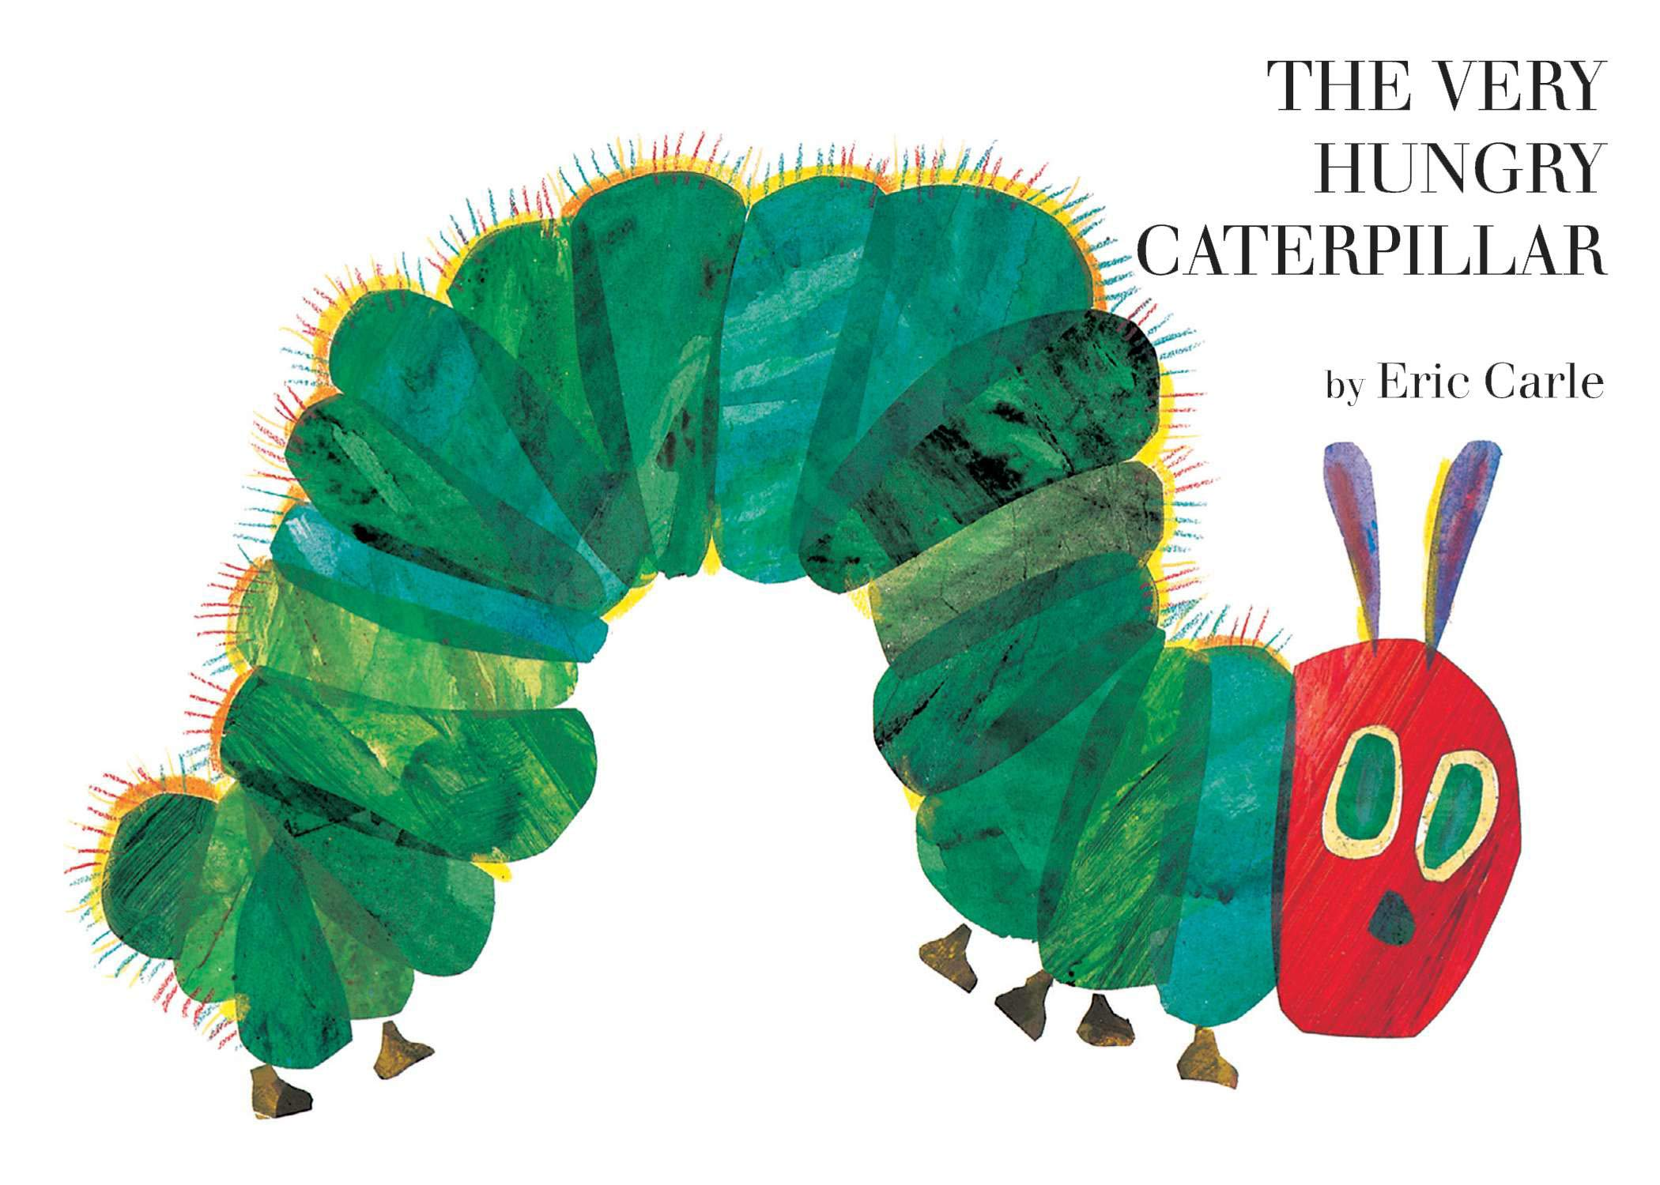

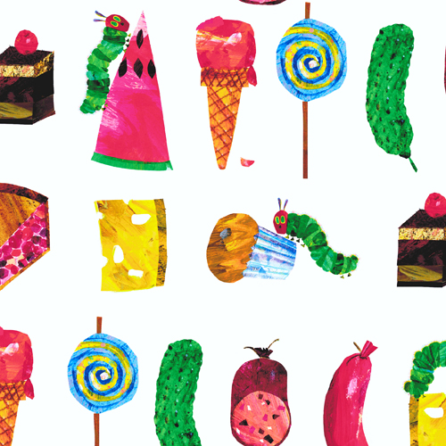

*The Very Hungry Caterpillar is one of my favorite books written by Eric Carle. The story is about a caterpillar that ate lots and lots of many different foods, before he turns into a butterfly. He ate apples, watermelon, pickles, cake, ice cream, lollipops, cheese, pie and much more!

*What are your favorite foods? What do you love to eat? Do you like some of the things that the caterpillar ate?

*Draw me a picture of ALL your favorite foods. Think of what you like to have for breakfast, dessert, dinner, snacks. Make sure you draw me 5 different foods.

*When you are done, share your picture with your family. Tell them what you drew. Ask them what their favorite foods are!